*Case Study 6.2:***Biking day with high carb lunch**

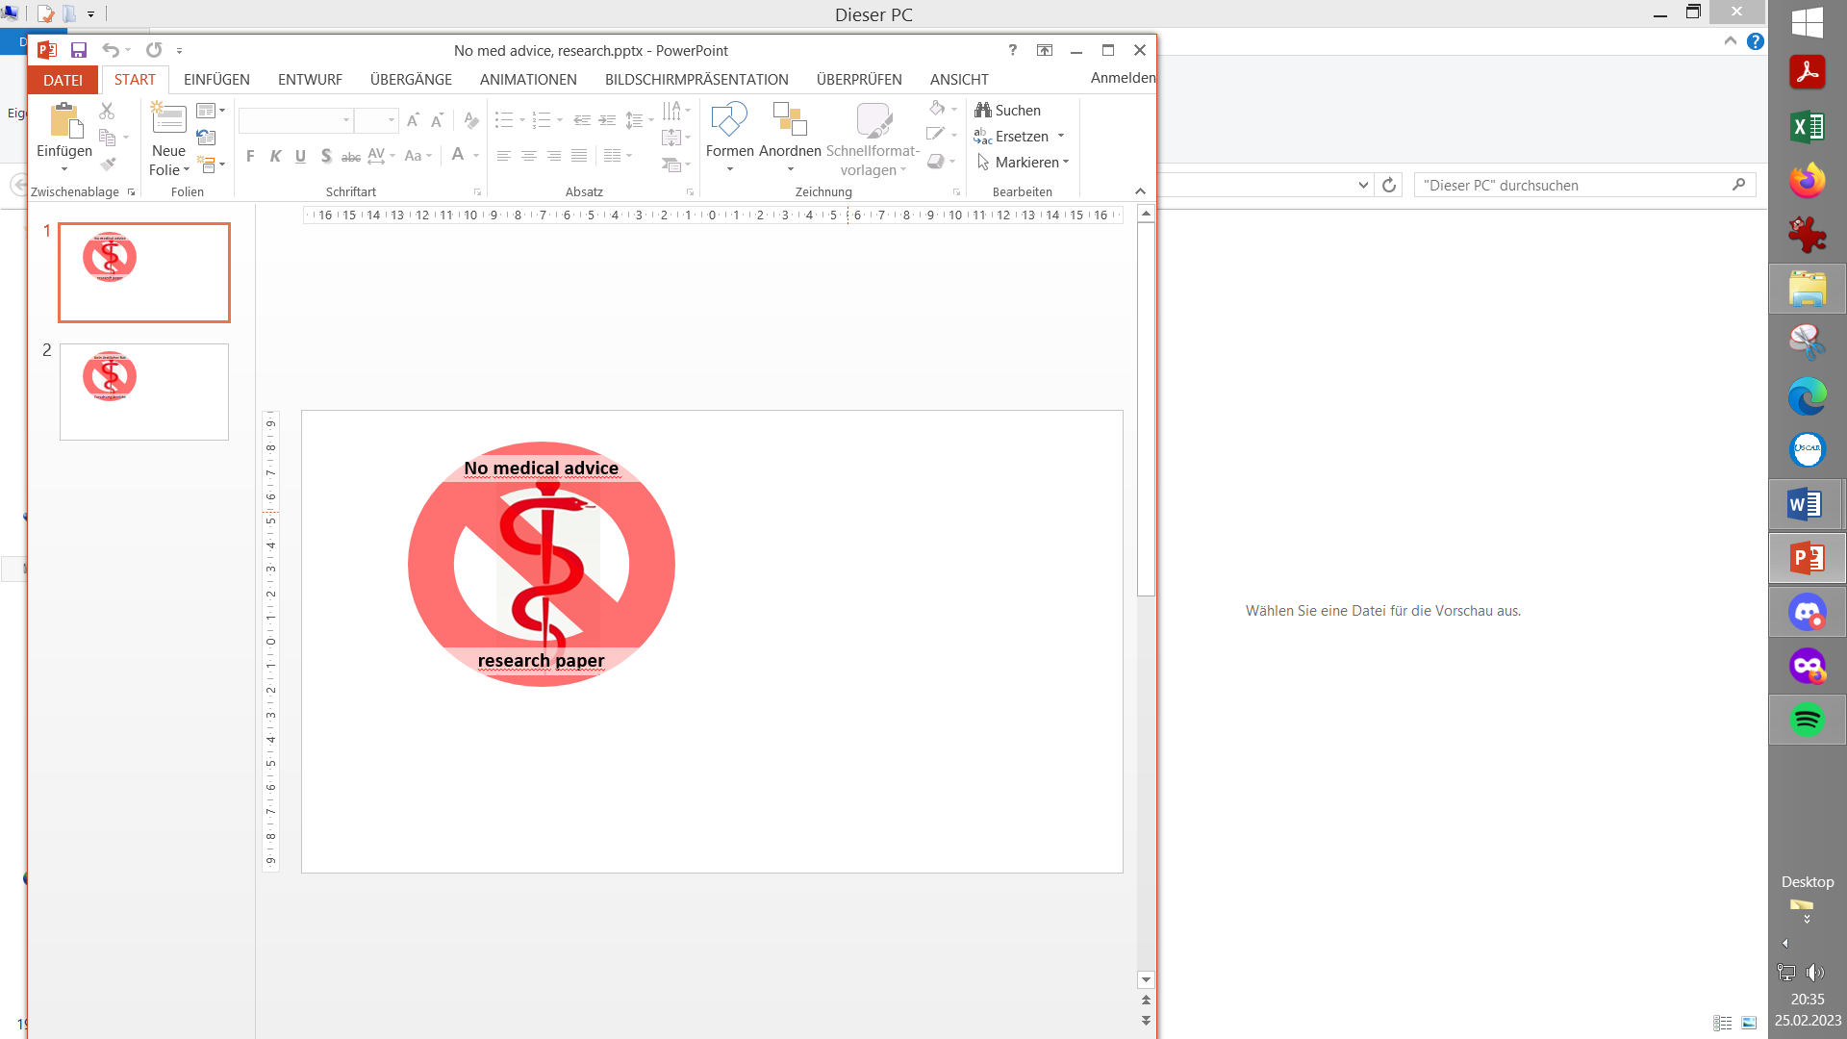

V.2.2

I set for most of the day a **70% profile**, and had only a minimal breakfast in order to keep iob low when starting to bike.

Additionally I activated the exercise mode, using a **TT=125 mg/dl** which I kept running over lunch time, but for a shorter period than the 70% profile.

About an hour before lunch time I reverted to profile target, and after lunch start an Automation can temporarily further lower the TT to 74 mg/dl to maximize first SMBs for the intended high carb lunch.

In just seconds I was able to „frame“ the upcoming exceptional situation for my loop, to manage me fully automatically through the day!

Of course, in my initial set-up and tuning, I had to first „learn“ from my looping data, where about %profile and set TT should lie for the kind of exercise that I was up to. But, no need to make a science out of it. Unless you are competing in professional sports, it should be good enough to go by gut feeling, and by experience („what setting should I slightly alter the next time?“).

Using the top button row on the AAPS main screen, I just input the 70% (for the whole day) and 125 mg/dl (for the first hours), which goes super fast and easy. It will immediately turn

* from all three fields grey,
* to „70%..“ on the profile field-turned-yellow, „125 .. „ in the TT field-turned-yellow, and also the exercise field lit yellow in the middle.

So, very easy to see on one glance, I am in the exercise mode, and which are the key settings (see picture with „95“ glucose below).

And in case I want to prematurely exit, or adjust a parameter, same easy procedure, just within 1-2 seconds, right from my AAPS home screen.

A **70% profile** was set for the entire day until dinner (AAPS screenshot) This modulates my 0.55 U profile basal to 0.7 * 0,55 = 0.39 U (see p.9, emulator-line 20)

**Exercise mode** with a **125 mg/dl TT** was set, translating into another (= getting multiplied) basal reduction of 33%%, to 67% of (70% of 0,55=)0,39U= 0,26 U (p.9, emulator-line 19).

The exercise mode also results in a **dynamic_iobTH** which, like basal, also goew lower:

These measures lead to a pretty overall glucose curve for this biking day, which included a fairly substantial lunch (duck, french fries, a fancy salad with fruit in it), as well a piece of cake at the end of the tour:

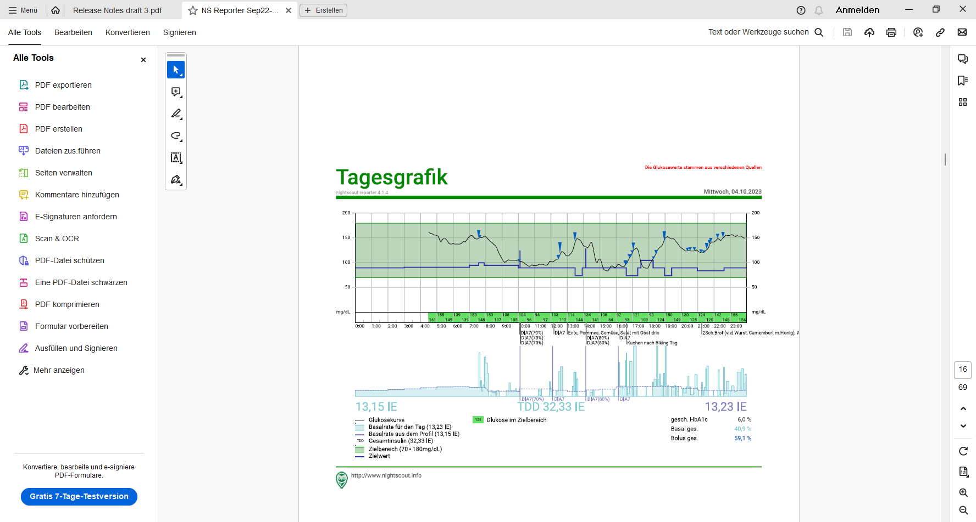

No carbs were entered into AAPS, no bolus was given by me.

The lunch iob hump in middle of the bottom graph of the next chart (below) shows that the 4.4 U iobTH was preventing higher iob as would be normal for a big lunch.

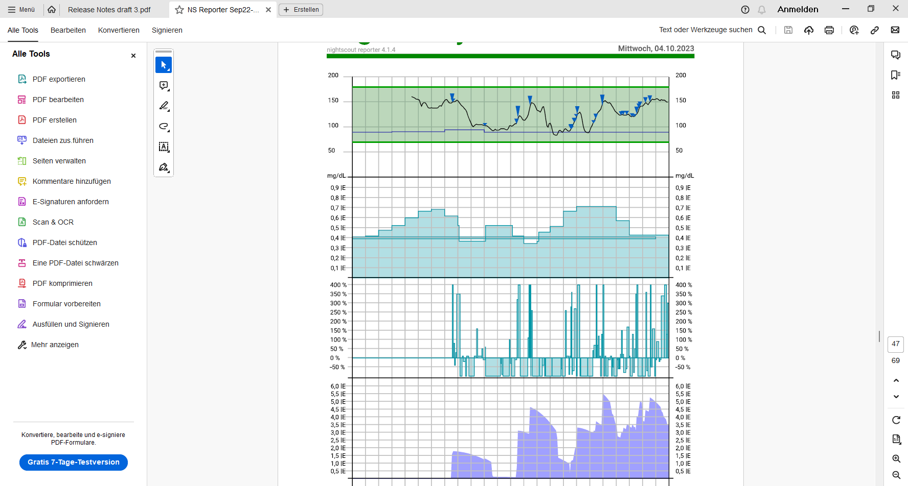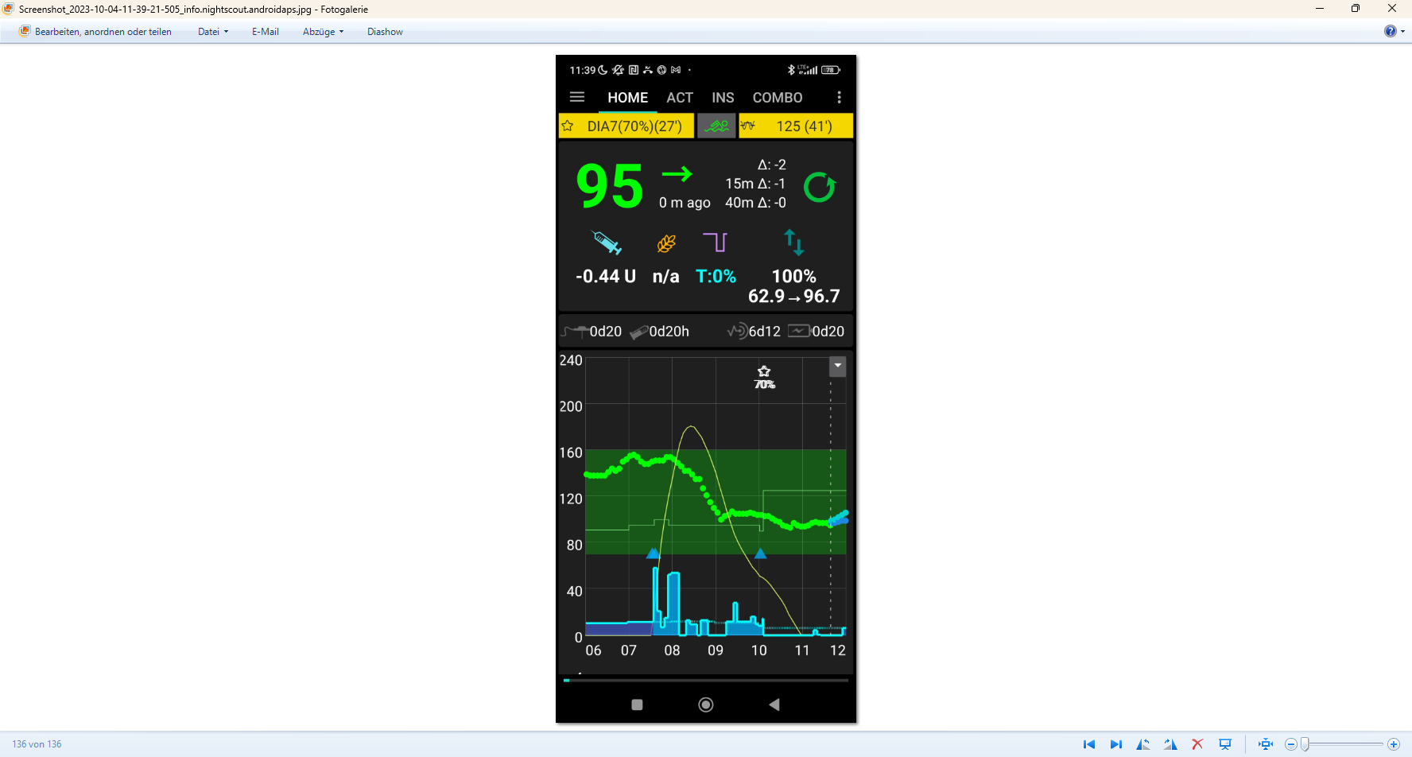

< **4.4 U**

Conclusions from this example

The example demonstrated that using the **exercise mode with a selected sports TT** will soften the loop response.

Background, how sensitivity ratio is automatically reduced (-> lower basal, higher ISF), and how dynamic_iobTH works in the exercise mode (-> lower iobTH, to reduce iob for meals on exercise days) see sections 3.3 and 6.4. The delta (how much higher the set exercise target is above profile target), and the half-basal-exercise target set in AAPS/preferences during your initial set-up define the sensitivity ratio the loop uses.

profile Target

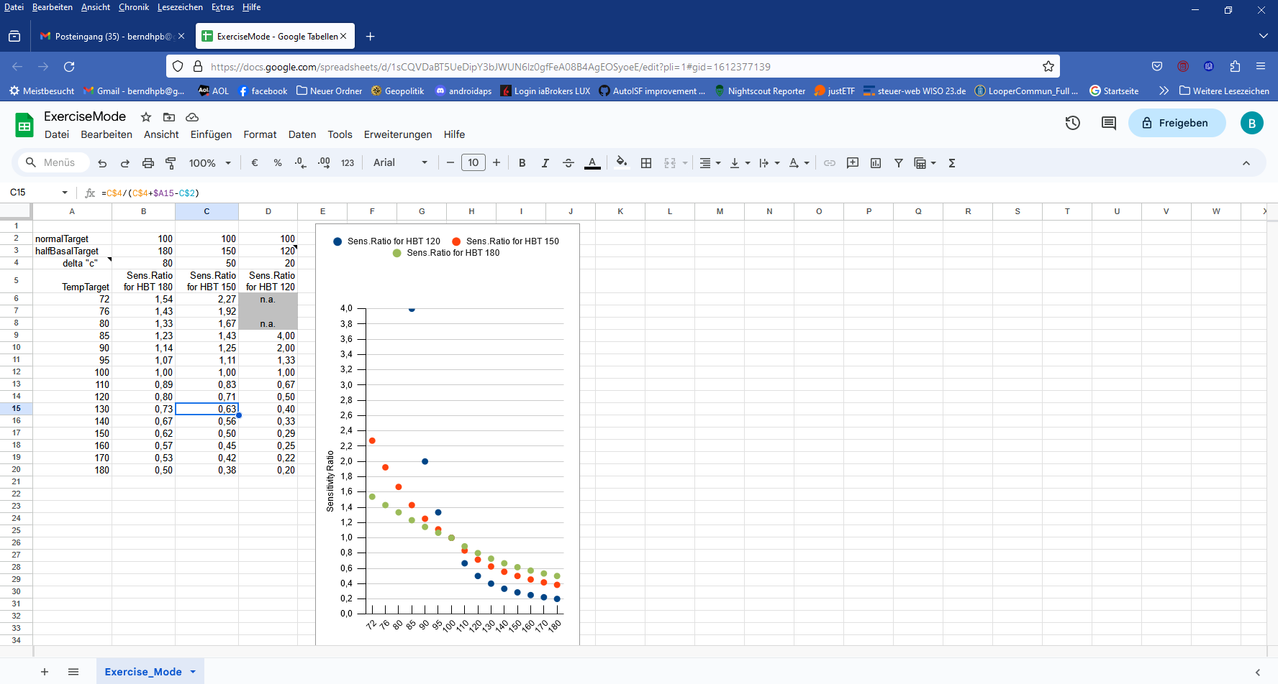

Table: Your general set half-basal exercise target set in Preferences (its distance to the valid profile target), and what TT you set in your exercise mode, lets you differentiate the desired loop aggressivenes.

Note that the **reduced temp.% profile** (on top of using the exercise mode with an elevated TT)multiplies with the results in above table, and further reduces basal *and also* iobTH. (which is also tied to the exercise mode and TT set, and effects multiply)

error in previous version corrected!

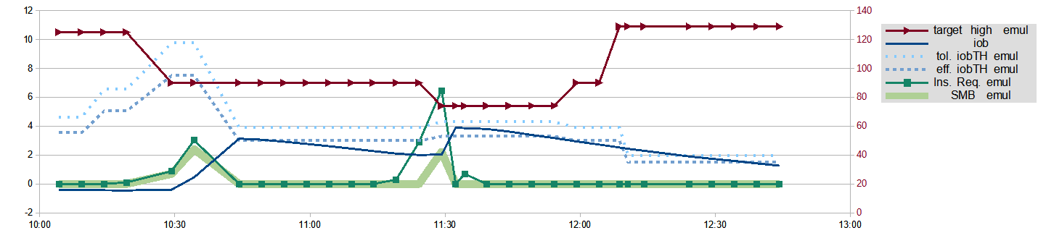

This chart from an emulator based analysis (by ga-zelle) shows nicely how iobTH (dotted blue lines) changes with the TT set (red line, and scale with red numbers on the right):

Shortly after 11:30 h the 74 mg/dl EatingSoonTT allows SMBs when below about 4U iob, And in fact my iob (blue curve) was limited, despite a high carb meal, at that level.

Around 12:00 h TT 74 expired and profile target briefly was set, followed within a couple of minutes by switching back (as before 10:15 h in the morning biking time) to the 125 mg/dl exercise TT. This state allows only about 2 U as iobTH (see kink in the blue dotted line at 12:10 h), and my iob (blue curve) came nicely down to that low level, as desireable for sports - but sure unusual so shortly after eating a substantial meal.

Not astonishingly, few SMBs are in the picture (fat green line mostly at zero) and the loop can handle carbs in an exercise dominated period nearly by just elevating basal (%TBR up to 400%). (Actually, the very first graph shows for around 13:30 glucose from the meal had risen to about 140 mg/dl and one additional SMB was necessary, and was also possible because from around 12:45 the iob (blue line) was below the (dotted blue line: lowered) iobTH again, as this graph shows.

Reaching and preserving good settings

For their kinds of favourite exercise, users must, over time, learn what combination of settings (half-basal_exercise_target,TT, %profile) leads to good-enough results.

As the loop re-calculates every 5 minutes, it is *not* important to get things *exactly* right. Automatic adjustments (every 5 minutes) allow the loop to still keep things under good-enough control.

The time windows for doing the profile switch, and for setting a suitable TT can differ (and they can also be automated, so not to require multiple inputs over the course of your exercise day). Using all available tools allows a nearly surgical approach to what you want to achieve for your favourite type(s) of exercise.

Instead of memorizing settings that work for your favourite types of exercise, you could keep them “shelved” in your AAPS to be called up when you do this or a similar exercise again.

For the DIY FCL cockpit you preserve your settings in Automations. A proposed improved user interface might provide settings also to be earmarked and stored in /preferences.

DIY FCL Cockpit

Luckily, the Automation options that are incorporated in AAPS 3.2… x autoISF 3… allow me to to create the cockpit elements for this case on my own:

* I detected this only afterwards, but I have it now available for any future similar exercise-after-meal events -

I need a sequence of 3 Automations, of which only the first one must be manually triggered, in just one time-uncritical key stroke from the AAPS home screen.

The others come on automatically when the respective Conditions are met.

Automation 1

The key first task was, to approach a meal that precedes exercise with full loop aggressive-ness, but to make sure that this aggressiveness stops immediately after a (reduced) iobTH is exceeded. The reduced iobTH ensures that not too much insulin is on bord for exercise after the meal. Also it provides an elevated bg level at (re-)start of exercise.

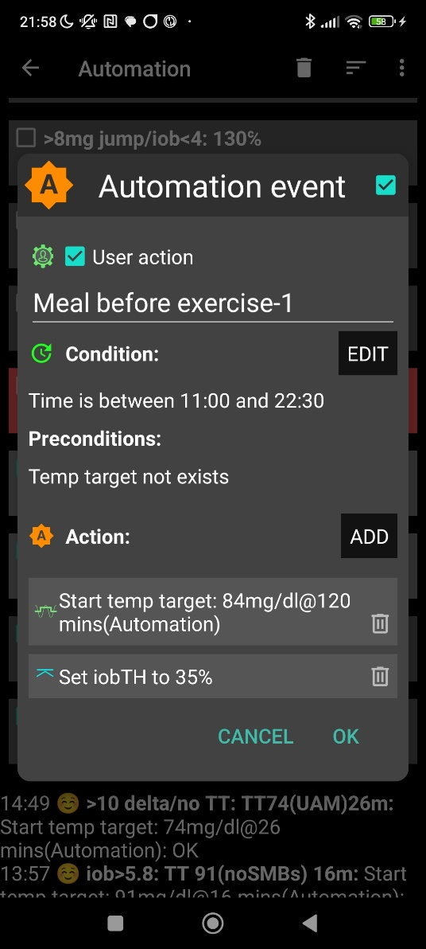

illustrative chart from another day

„User action“ is always ticked-on

This will, in the defined time space *) ..

..offer the “DIY cockpit” button..

..which I must press any time (~90…30 minutes) before my lunch.

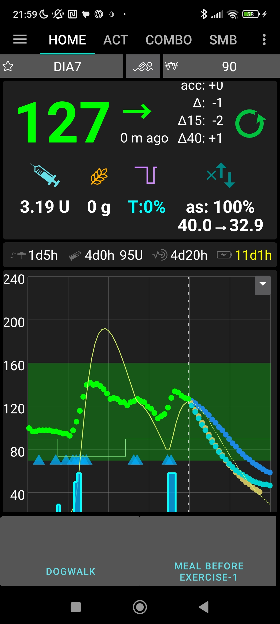

In this Automation, the box “User action” should be permanently ticked. This will automatically provide a grey button on the bottom of my AAPS home screen (“DIY cockpit”) that I can freely name (= headline of my Automation).

To keep the AAPS home screen as clean (and relevant) as can be, that button will show only in the time slot as specified under Conditions.

*) It will be reduced to something realistic. Only for development and testing purposes it had to extend into the night.

Automation 2

When (my in Automation 1, for exercise following the meal, to 35 % reduced iobTH that translates for me into) iob>3.8 is exceeded, I want two things:

1. The loop shall now automatically run milder, on my reduced exercise %profile (70%)(after the meal rise had been managed based on 100% profile, boosted by bgAccel_ISF driven full loop aggressiveness).
2. I like also to set a exercise TT. This, however, is not possible. I first have to force an end to my EatingSoonTT of 84:

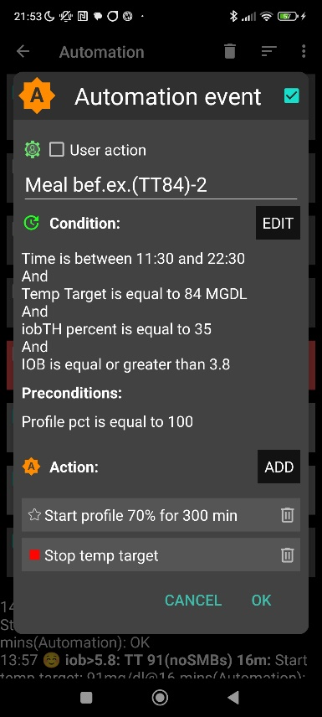

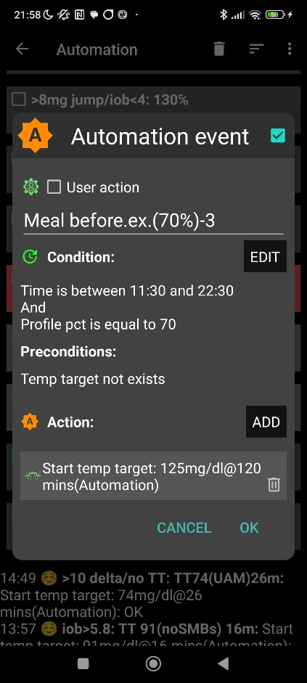

Automation 3

Now, that Automation 2 ended my TT of 84, Automation 3 can (max 5 minutes later) set the desired exercise TT=125 (which implies the exercise mode as in detail explained before).

Note that Automations 2 and 3 are fully automatic, no User Action involved.

Should during my exercise a need arise to modulate the loop aggressiveness (iobTH, effective ISF) I could do this within 1-2 seconds also right from the AAPS home screen („FCL cockpit“) by setting a higher or lower temp. %profile, and/or by setting a higher or lower temp. exerciseTT.

To make the loop act a bit more aggressive, switching the exercise button OFF (from yellow to grey) could also be considered

Finding User action - Automations to build your FCL cockpit

**If you want to develop your DIY User Interface make sure you define suitable settings that reflect your personal insulin sensitivity and data patterns.**

As mentioned in other places, Automations can be tricky as to whether they actually will ever work, because the loop goes through the exact **sequence of all your active Automations**, and might be switched into a direction that no longer is compatible with the conditions that must be a given, for the Automation you think that should kick in.

To have a clean AAPS home screen (and also to prevent unnecessary accidential activation), define reasonable time windows for each of your shelved special routines, or keep them entirely dormant (de-activated) in the list of all your Automations, and activate them for the day when you think you might need them.

Improved FCL Cockpit

With the *suggested* improved cockpit user interface *(*section 5.3 *and* 6.3*)*, I could have gone through the day with just one time un-critical step (as discussed in section 6.5.2 ).

Should during my exercise a need arise to stop a selected mode, or to change a setting, I could do this within 1-2 seconds also right from the AAPS home screen („FCL cockpit“).

Skip all following pages, unless you like to learn more about Logfile analysis using the emulator

Logfile analysis with the emulator

Skip this last section, unless you like to learn more about using the emulator.

Analysis of my biking day with the emulator required to load the logfiles from my phone into the PC, and to have the files for the emulator downloaded from Github.

1. Load an empty vdf file, and access to logfiles (erasing the end with UTZ time, and putting an asterics after date_ => all of that date get loaded into the mask
2. Define the time window of interest, using UTZ (= MEZ summertime minus 2) in the last two lines (right hand side input fields) of the form:

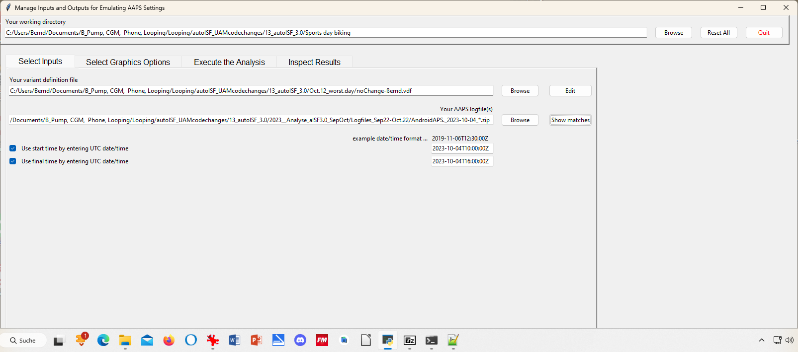

1. Execute Analysis / Run Emulation yields results as table:

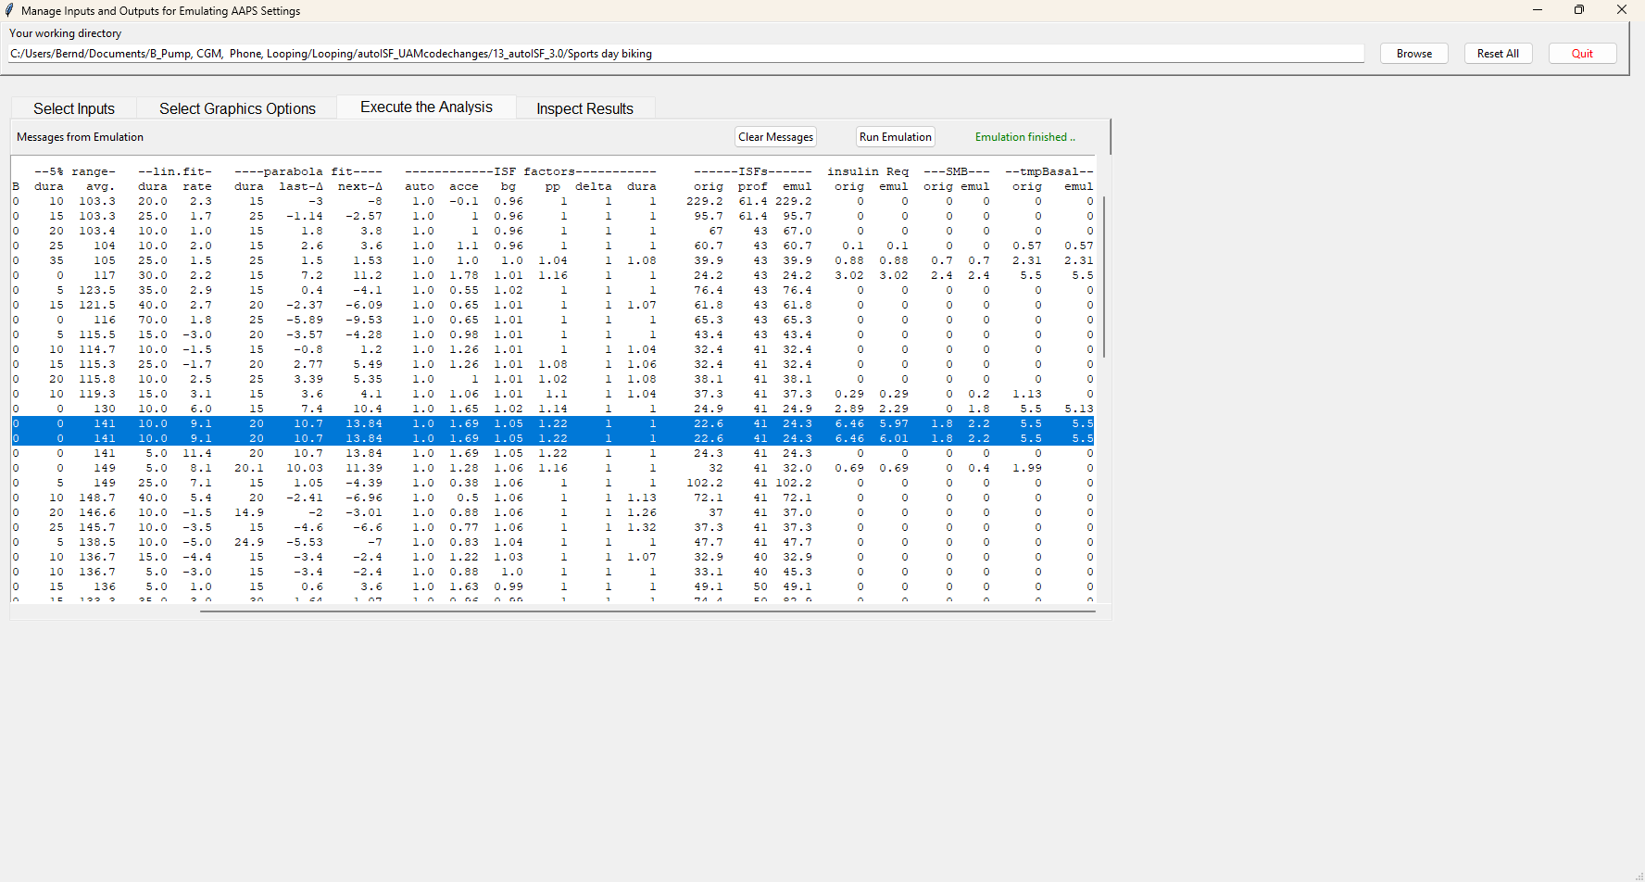

In line 6 (12:34 CET) a 2.4 U big SMB is given, driven by bgAcel_ISF factor of 1.78

Highlighted is 13:29 CET (for some reason there is duplicated line for it). Here, a big insulinReq of 6,5 U is cut down to a SMB of only 1.8 U..

1. … to see how our settings, TT and and sports button worked here, and what iobTH applied, we must look into the logs available from: ((alternatively, the SMB tab from exactly those 5 minutes would show, too))

Instead of Execute Analysis, press Inspect results…



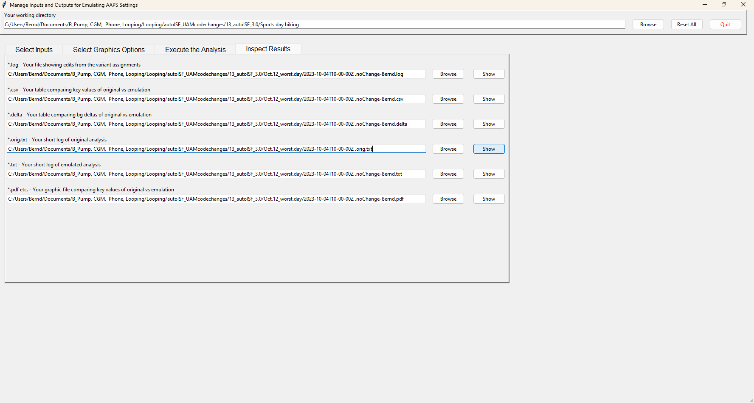

If you press the 4th option you get the logs which include basically all SMB tab info in an exhaustively long list.

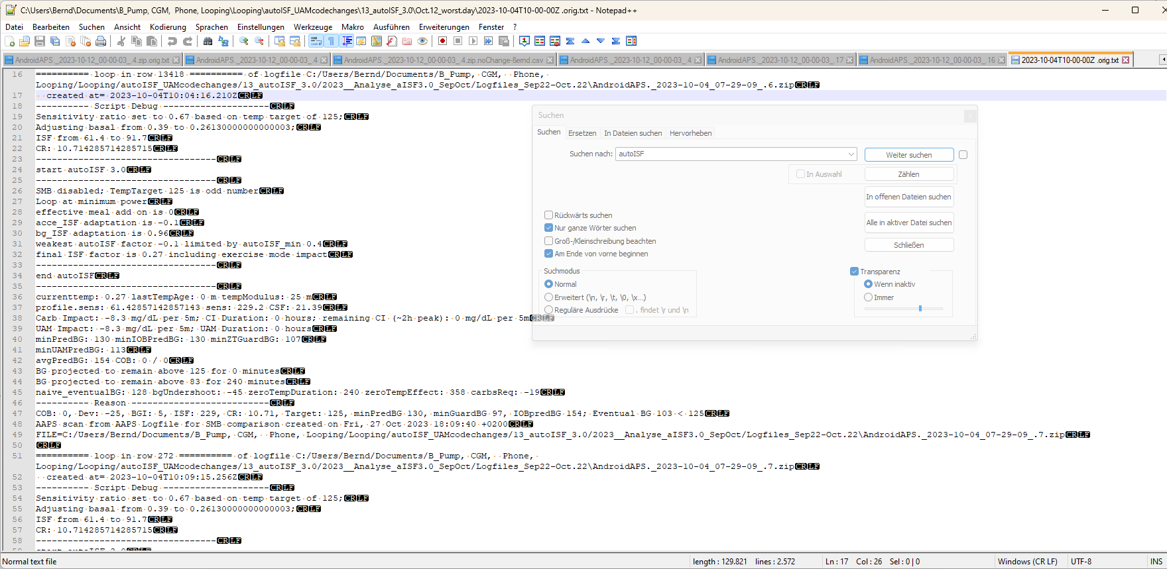

The blue highlighted line shows we are at 10:04 UTZ (12:04 CET) . We can see how sensitivity ratio and also basal were lowered due to sports setting with a 125 mg/dl TT, or 129 used a bit later, which also disabled SMBs.

By using the search function you can jump, in that long list, to all places that e.g. have „autoISF“ in it, or „script debug“, or „SMB disabled“ (if you want to analyze when that happened…)

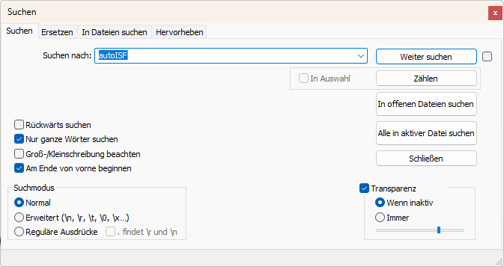

1. Now lets look at 11:29 UTZ (13:29 CET) which was when the first relevant size SMB was issued:

In the following, I copy and shorten texts from the log table as above, for some time points of high interest:

11:29 UTZ (13:29 CET), when SMB was delivered:

loop in row 14007 …..created at= 2023-10-04T11:29:11.005Z

---------- Script Debug --------------------

Sensitivity ratio set to 1.1 based on temp target of 74;

Adjusting basal from 0.55 to 0.6050000000000001;

ISF from 41 to 37.3

CR: 7.5

So, we see the meal TT of 74 (set by one of my Automations for cases in which I did not bother to set an EatingSoonTT) temp. overrides the exercise target and sharpens the applicable ISF: ((It also elevates basal ; note that TBRs can run several 100% of basal))

----------------------------------

start autoISF 3.0

----------------------------------

SMB enabled; TempTarget 74 is even number

Loop at full power

acce_ISF adaptation is 1.81

bg_ISF adaptation is 1.05

pp_ISF adaptation is 1.22

dura_ISF by-passed; bg is only 0m at level 141

final ISF factor is 1.81

----------------------------------

end autoISF

----------------------------------

profile.sens: 41 sens: 22.6 CSF: 3.01

minPredBG: 220 minIOBPredBG: 135 minZTGuardBG: 94 minUAMPredBG: 231

avgPredBG: 220 COB: 0 / 0

BG projected to remain above 74 for 240 minutes

IOB 2.033

Full loop capped SMB at 1.87 to not exceed 130 % of effective iobTH

Here we see that our, for the exercise day significantly lowered, iobTH not only blocked SMBs above that lower threshold. Also the 30% “the last” SMB is max. allowed to go beyond the valid iobTH now amounts to significantly less.

So, while, as intended for start of a high carb meal, my loop is at full power (line 209), the last SMB (line 223) got capped to way below insulinReq (line 231).

… maxBolus: 3.2

---------- Reason --------------------------

Eventual BG 304 >= 74, insulinReq 6.46. Microbolusing 1.8U. adj. req. rate: 13.53 to maxSafeBasal: 5.5, temp 2.75 < 5.5U/hr.

1. A look at the cake after 14:20 (16:20 CET):™

From 14:09 UTZ (16:09 CET) on, I discontinued the sports TT and the loop reverted to 90 mg/dl profile target.

As desired for starting to eat cake, this made SMBs possible, and the only reduction of FCL aggressiveness was the 70% due to temp. profile set for this sports day.

However, 14:14 - .19 - .24 and :29 there was no insulinRequired yet (while ISF factor gradually ramped up from 0.52 to 1,09 (line 1735, 1772, 1807) .

At 14:34 UTZ (16:34 CET) a first cake related SMB of 0.5 U was issued based on 0,66 U ins.Requ (line 1897), and based on a bgAccel_ISF factor of 1,54 (and final ISF factor of 1,52).

As there is a **>10 mg/d delta** (glucose rise), **my Automation** kicks in and sets for the next loop decisions (for 26 minutes is as my Automation defines it) a **TT=74** mg/dl which makes the loop more aggressive from 14:37 on:

created at= 2023-10-04T14:37:15.371Z

---------- Script Debug --------------------

Sensitivity ratio set to 1.1 based on temp target of 74;

Adjusting basal from 0.48 to 0.528;

ISF from 39 to 35.5

CR: 6.6

----------------------------------

start autoISF 3.0

----------------------------------

SMB enabled; TempTarget 74 is even number

Loop at full power

acce_ISF adaptation is 1.64

bg_ISF adaptation is 1

pp_ISF adaptation is 1.08

dura_ISF adaptation is 1.11 because ISF 35.5 did not do it for 30 m

final ISF factor is 1.64

----------------------------------

end autoISF

----------------------------------

profile.sens: 39 sens: 23.8

avgPredBG: 94 , BG projected to remain above 74 for 240 minutes

IOB 0.438 Eventual BG 100 >= 74, insulinReq 0.84. Microbolusing 0.6U.

created at= 2023-10-04T14:39:16.537Z

---------- Script Debug --------------------

Sensitivity ratio set to 1.1 based on temp target of 74;

Adjusting basal from 0.48 to 0.528;

ISF from 39 to 35.5

CR: 6.6

----------------------------------

start autoISF 3.0

----------------------------------

SMB enabled; TempTarget 74 is even number

Loop at full power

effective meal add on is 0.04

acce_ISF adaptation is 1.25

bg_ISF adaptation is 1

pp_ISF adaptation is 1.06

dura_ISF by-passed; bg is only 5m at level 97.5

final ISF factor is 1.25

----------------------------------

end autoISF

----------------------------------

profile.sens: 39 sens: 31.2

avgPredBG: 78 BG projected to remain above 74 for 240 minutes

IOB 1.114

Eventual BG 84 >= 74, insulinReq 0.13; setting 30m low temp of 0.04U/h. Microbolusing 0.1U.